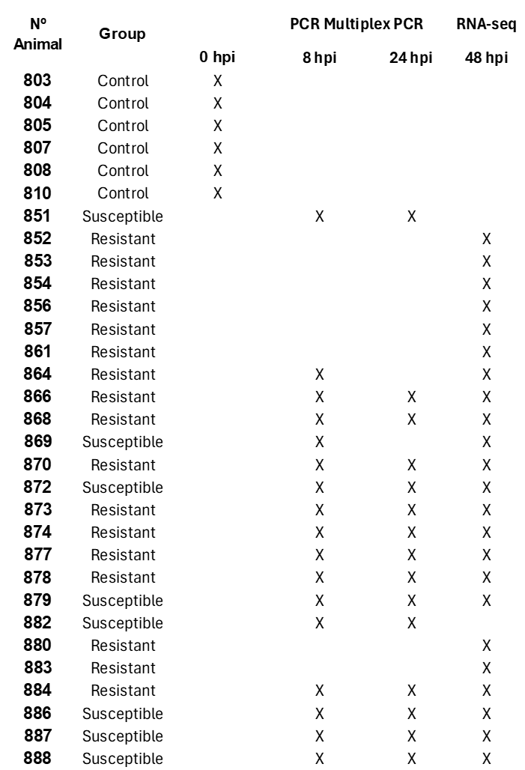

**Supplementary Table 1.** Summary of analyses performed on whole blood samples collected from controls, HPAIV-resistant, and HPAIV-susceptible chickens. Samples collected at 48 hours post-inoculation (hpi) were analyzed using RNA-seq, while samples from 8 and 24 hpi were quantified using Multiplex PCR Fluidigm. Due to the onset of mortality at 48 hpi, the number of susceptible samples analyzed was limited, as not all susceptible animals could be sampled before death. Additionally, only samples with high RNA quality were selected for further analysis. Samples from noninfected chickens (negative controls) were collected at 0 hpi.

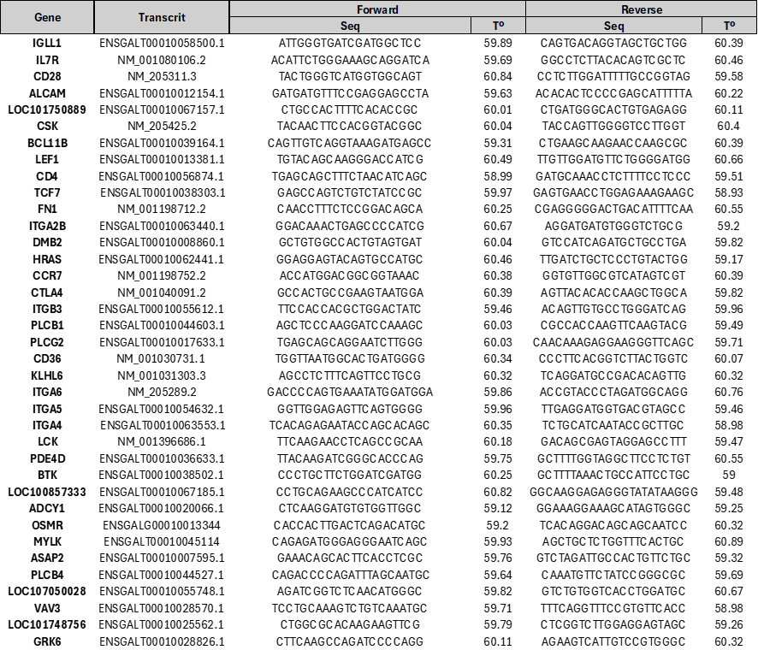

**Supplementary Table 2.** Primers and melting temperatures for selected genes were included in the PCR Multiplex Fluidigm assay, using samples from control, HPAIV-resistant, and -susceptible birds collected at 8 and 24 hpi. These genes were chosen from the adaptive immune pathway, genes that appeared in multiple relevant pathways, and others that were not categorized within DAVID pathways but showed high logFC values.



**Supplementary Table 3.** Total number of chickens experimentally infected with H7N1 HPAIV and euthanized at 48 and 72 hpi. Birds were classified as resistant or susceptible based on clinical score (0: normal; 1: mild; 2: moribund/severe; 3: deceased); histopathology lesions (I: inflammation; N: necrosis); positive immunohistochemical (IHC) staining (-: no positive cells; +: <10% positive cells; ++: 10-40% positive cells; +++: >40% positive cells); and oropharyngeal (OP) and cloacal (CL) viral shedding with Ct values below 33. *Not evaluated due to autolysis.

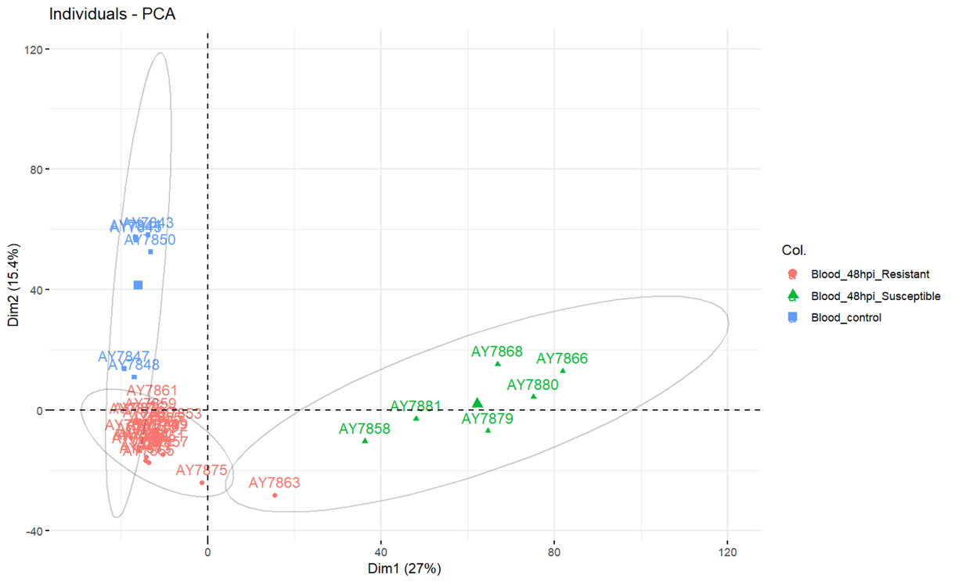**Supplementary Figure 1.** Principal Component Analysis (PCA) of gene expression data of RNA from whole blood samples from controls (0 hpi), HPAIV-resistant (48 hpi), and -susceptible (48 hpi) chickens. The analysis was performed on log-transformed data after normalization using the “limma-voom” method. Each point represents an individual sample, color-coded based on the experimental group (red for resistant, green for susceptible, and blue for control). The ellipses represent the 95% confidence intervals for each group. The following outlier samples were identified and excluded: AY7846 (806) and AY7849 (809) from the control group; and AY7859 (860), AY7861 (863), AY7863 (865), and AY7875 (881) from the resistant group.

**A**

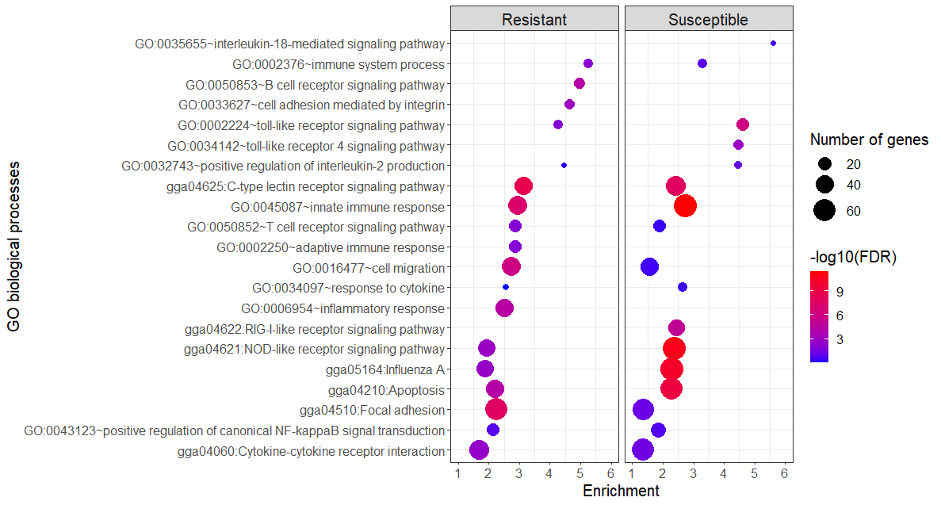

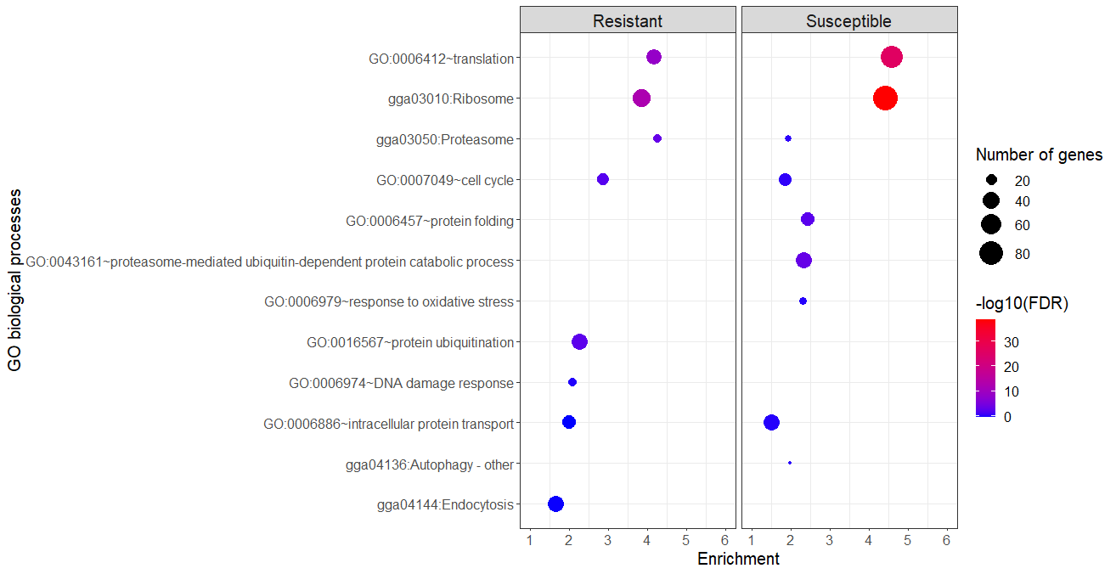**B**

**Supplementary Figure 2**. Pathway enrichment analysis of the most significantly enriched Gene Ontology (GO) Biological terms for upregulated (**A**) and downregulated (**B**) differentially expressed genes (DEGs) in whole blood of HPAIV-resistant and -susceptible chickens collected at 48 hpi. The color of the dot indicates the significant enrichment, measured using -log10 of the false discovery rate (FDR), while the size of the dot corresponds to the number of DEGs associated with each term.



**Supplementary Table 4.** List of Gene Ontology (GO) terms and associated genes enriched in differentially expressed genes (DEGs) exclusively identified in HPAIV-resistant chickens at 48 hours post-infection (hpi). This table includes innate immune response, MAPK signaling pathway, adaptive immune response, B cell receptor signaling pathway,T cell receptor signaling pathway, and integrin-mediated signaling pathway.